NPU student number:
2023304252

QMUL student number:
231199018

Title of case study:
Supor Electric Whisk Product Evaluation

Final word count (excluding references):
1611

Engineering group number:
M18

English group number:
Group 4

Supor Electric Whisk Product Evaluation
- Introduction
This report will introduce the Supor electric whisk in product design, material selection, production process and suggested improvements. The Supor electric whisk is a versatile kitchen appliance, mainly suitable for mixing, kneading, and whipping various ingredients to prepare various dishes. [1]
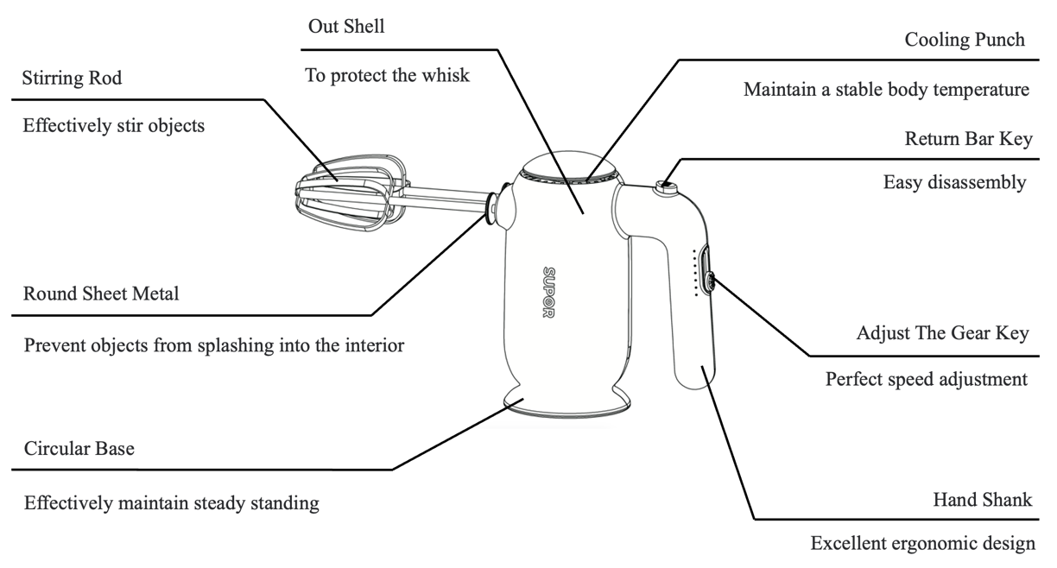
Figure. 1 Part of the subassemblies, design elements and components of the Supor electric whisk

Figure 1 shows the subassemblies, design elements and components of the Supor electric whisk. As shown in Figure 1, the electric whisk mainly consists of an outer shell, two stirring rods, an adjust the gear key, a hand shank, a return bar key, and a cooling punch.

No. | 1 | 2 | 3 | 4
Diagram | 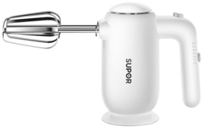 | 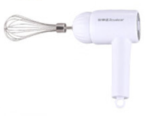  https://item.jd.com/100061065520.html | 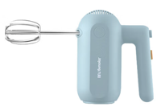  https://item.jd.com/100026716322.html | 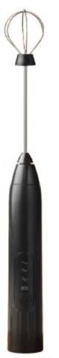  https://item.jd.com/100098725714.html
Price | 78.00 CNY | 29.90 CNY | 57.00 CNY | 29.90 CNY
Size | 17.2*8.5*14.6cm | 20*16*10.8cm | 26.5*7.2*16.5cm | 31*3.3cm
Gear | 1-6 | 1-3 | 1-5 | 1-3
Bright  features | Return bar key;  Heat-removal system;  Stable base | Rechargeable;  Two kinds of mixing sticks;  Tail hole | Return bar key;  Heat-removal system | Rechargeable;  lightweight and compact

Table. 1 Price and highlight feature comparison chart for some similar whisks[1][2][3][4]

As shown in Table 1, the price of a single Supor electric whisk is about 78.00 RMB, which is higher than the price of a single similar product (29.90 to 57.00 RMB). In addition to the difference in price, the Supor electric whisk and other similar whisks also differ in function and composition.

In comparison to the second and fourth whisk in Table 1, the Supor electric whisk has a base to keep it stable, but a ring at the end of the second whisk allows it to hang from the wall. Besides, the second and fourth whisk can be charged. [2][4] On the other hand, compared to the third whisk in Table 1, the Supor electric whisk has 1-6 adjustable gears which is more than the third one, 1-5. [3] Moreover, they both have a return bar key and heat-removal system. In the final analysis, although the Supor electric whisk is higher than the other three in terms of price, it has the most adjustable gear, an excellent heat-removal system and can be stably placed on the table.

Regarding user requirements, the electric whisk is expected to be ergonomically designed, ensuring comfort during use and reducing the risk of hand fatigue. [5] It should also be simple to operate, with an intuitive interface that allows users to easily switch between speeds and functions. [5] Additionally, the whisk should be capable of efficient mixing, even in challenging situations such as thick batters or when a thorough blend is required.[5] Ultimately, the Supor electric whisk balances performance, convenience, and safety, making it perfect for efficient kitchen tasks without compromising quality.
- COMPONENT SHELL
No. | Part Name | Figures | Material | Manufacture Process
1 | Shell | 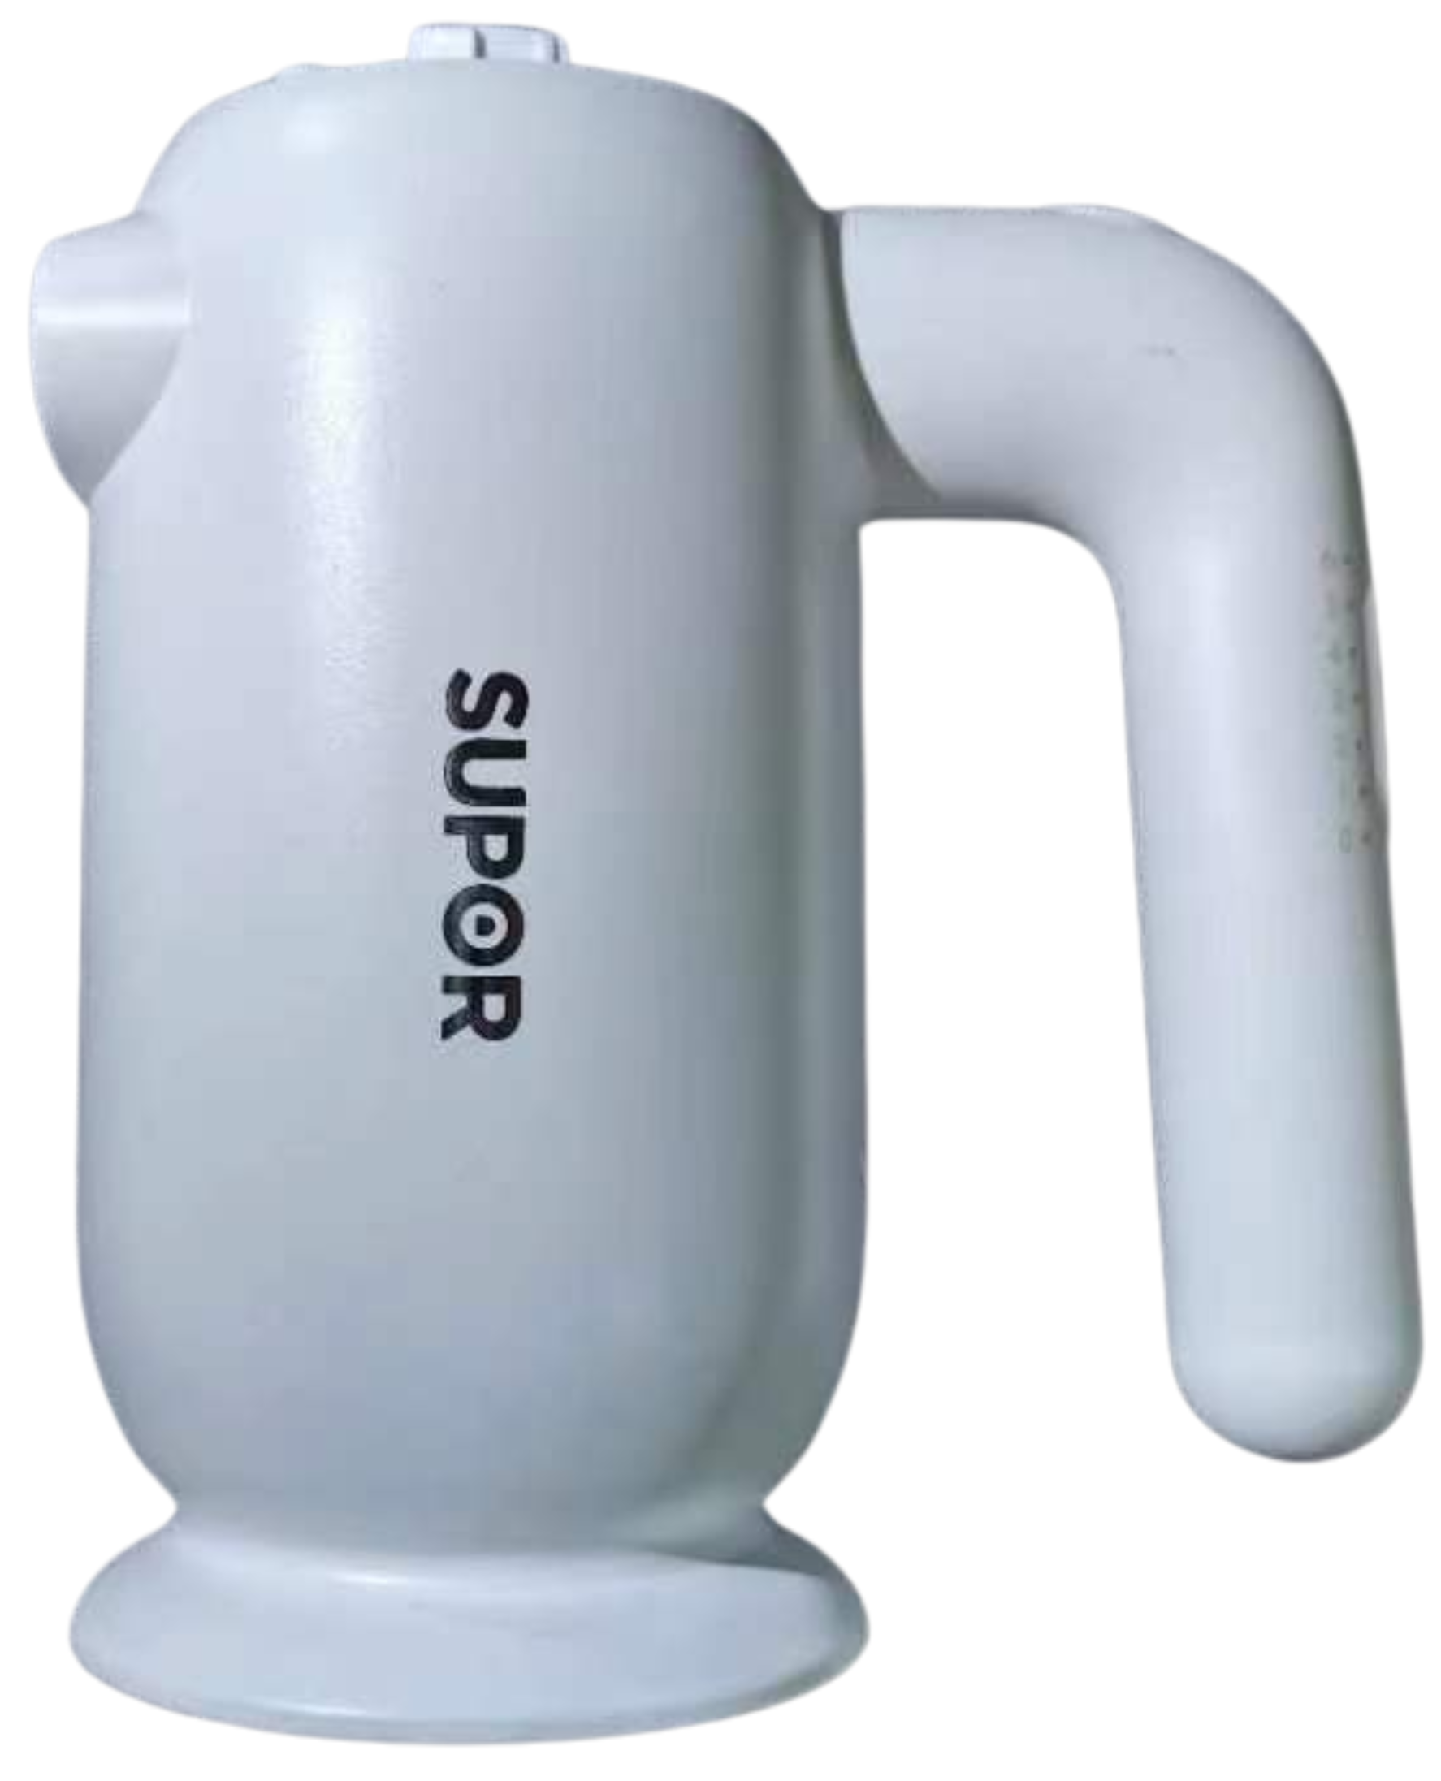 | Plastic (PBS) | Injection Molding
2 | Pedestal | 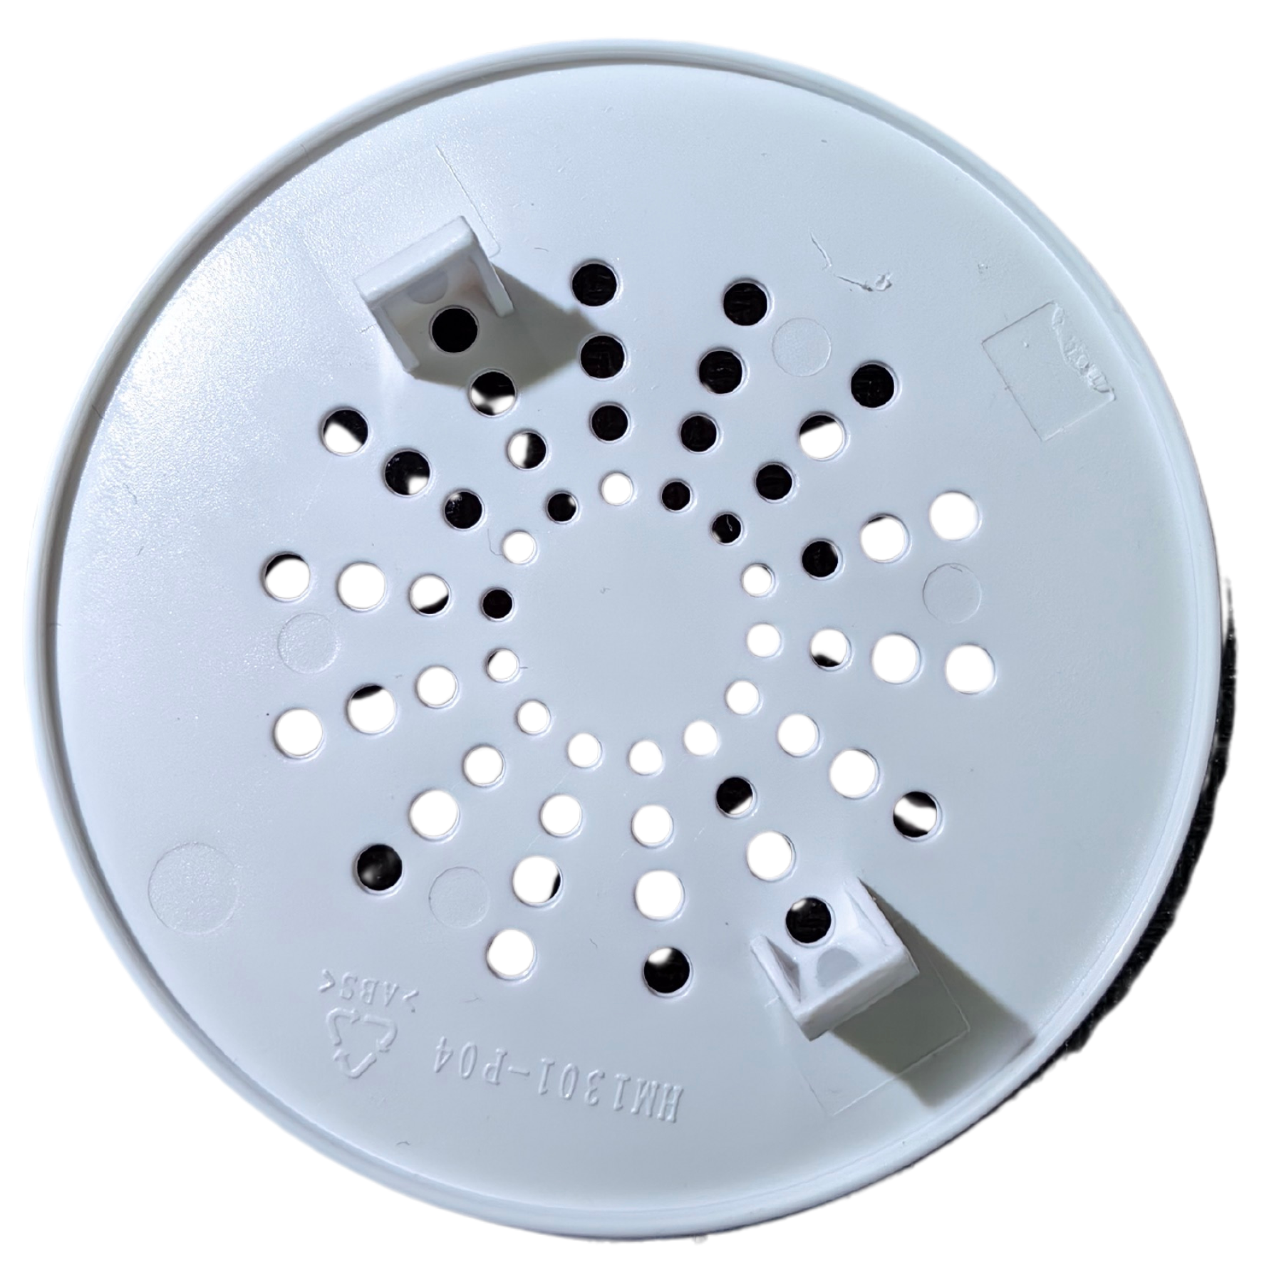
3 | Top Protective Housing | 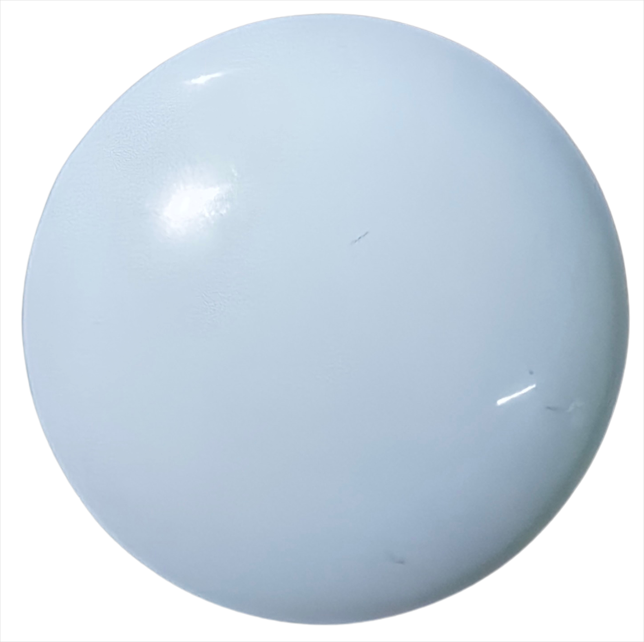
4 | Return Bar Key | 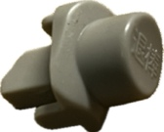 | Plastic  (PA66 GF30) | Injection Molding
5 | structural support | 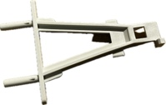
6 | The Gear key | 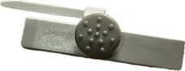
Table. 2 Materials and manufacture of the component shell of the Supor electric whisk[6][7]
2.1 Design
The component shell forms the basis of the entire design, as it covers the surfaces of all Supor Electric Whisk components. The component shells include left and right casing, motorcase, switch, and other smaller parts(items 1-6 in Table 2).

All components' housings are made from materials that are easy to clean, non-toxic, and have a long lifespan, meeting the requirements for kitchen use. The ergonomic design of the handle ensures that users do not experience fatigue during prolonged use. Additionally, the base allows the mixer to stand stably on the table when not in use, preventing contamination. The speed of the mixer can be adjusted via a toggle switch to accommodate the mixing of different substances. By pressing a button, users can quickly detach the mixing rod, making the appliance convenient and simple to operate (Figure. 2).
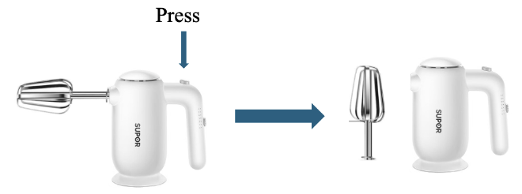
Figure. 2 The process of removing the mixing rod by pressing
2.2 Material
The component shells are made of ABS plastic (Acrylonitrile Butadiene Styrene) and PA66 GF30 plastic (Polyamide 66 With 30% Glass Fiber) (Table 2). Both ABS and PA66 GF30 share characteristics such as being relatively non-toxic and cost-effective (current prices are approximately $2.50 to $3.50 per pound), [8] as well as being capable of withstanding repeated impacts and resisting chemical degradation .[9][10]

During the operation of the electric whisk, parts of the component shell come into direct contact with users and food. Therefore, the materials used for the component shell must be non-toxic, safe, and comfortable. Because the user in the use of the whisk will continue to produce vibration, and a small amount of food directly touches the shell. The component shell must also endure repeated impacts and be chemically resistant to ensure that the electric whisk’s service life is not significantly reduced during high-intensity usage. According to the analysis, ABS and PA66 GF30 meet these food-grade materials requirements. [9][10]

There are notable differences between ABS and PA66 GF30. ABS is easy to process, reducing production costs. In contrast, PA66 GF30, reinforced with glass fibers, can withstand higher mechanical stresses and can tolerate short-term temperatures up to 260°C, making it ideal for components exposed to high thermal and mechanical loads. The use of PA66 GF30 material in some key parts can ensure the durability and reliability of the electric mixer under harsh conditions and meet the needs of users.

2.3 Manufacture
ABS and PA66 GF30 are thermoplastic materials suitable for blow molding to achieve desired shapes. Injection molding involves heating the thermoplastic polymer above its melting point to convert it into a molten fluid of low viscosity. This process is efficient, cost-effective, and crucial for mass-producing component shells rapidly. [6][7] Once molded into the desired shapes, these component shells can be assembled either manually or using automated assembly methods.

- ELECTRICAL COMPONENTS
No. | Part Name | Figures | Material | Manufacture Process
1 | Fan | 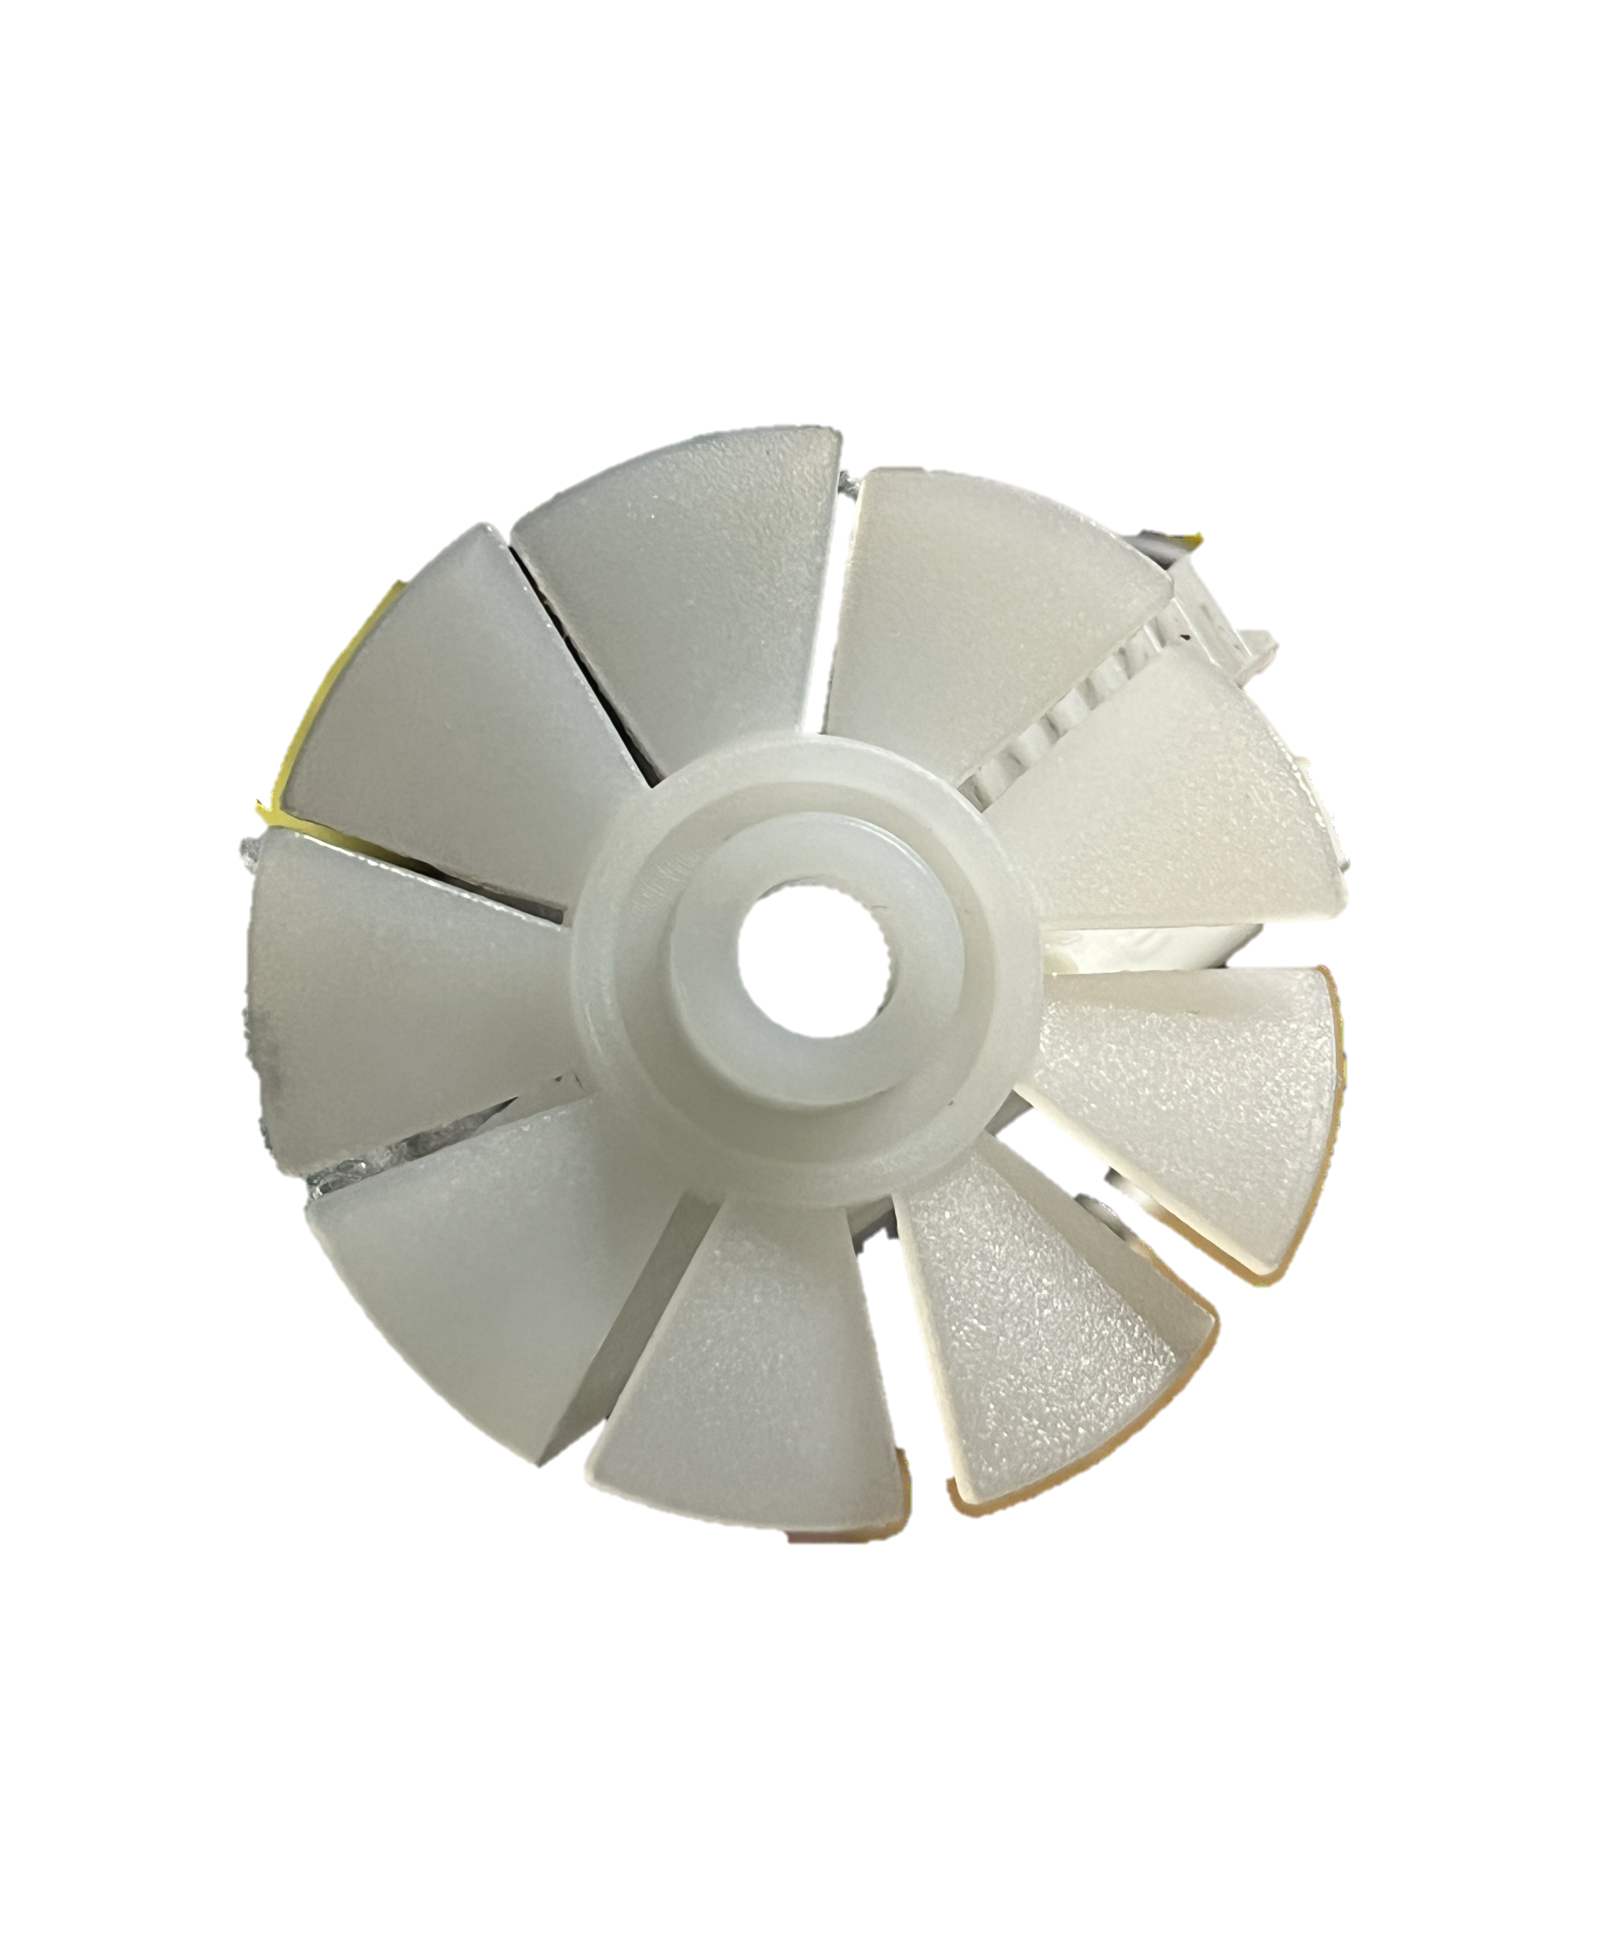 | ABS | Injection Molding
2 | Gear | 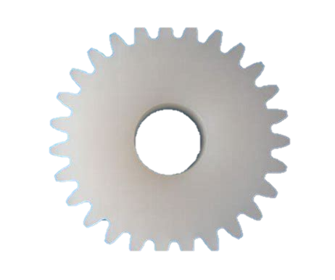
3 | Rotor Core | 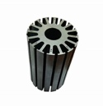 | Stainless Steel | Milled
4 | Axle | 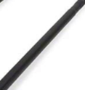
5 | Stator Core | 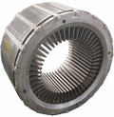
6 | Screw | 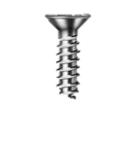
7 | Coil | 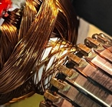 | Copper | Extrusion
8 | Stirring Rod | 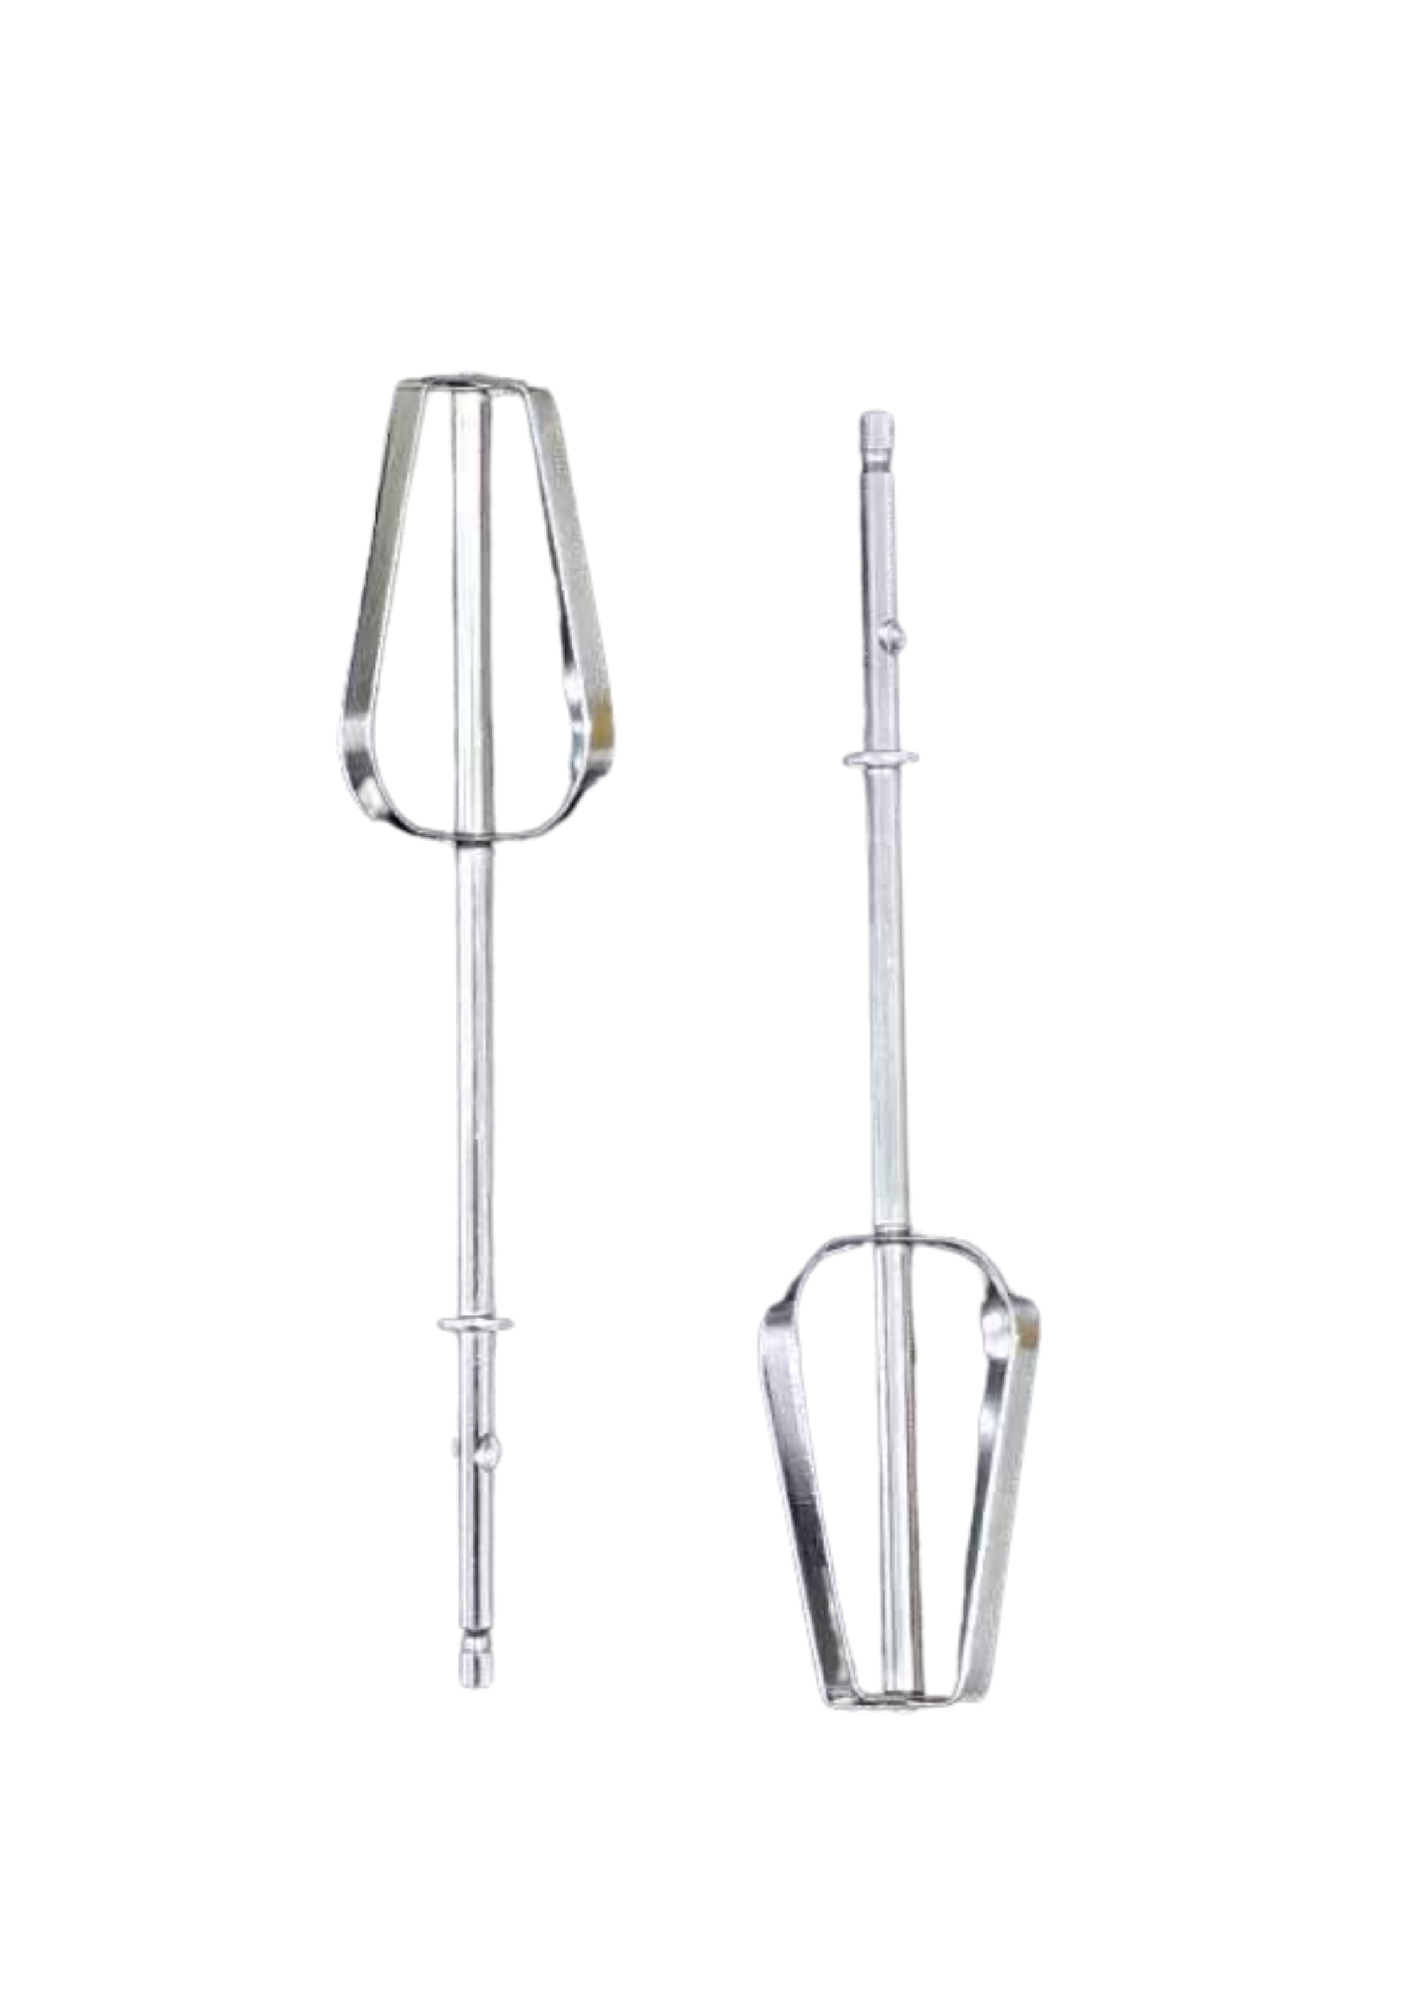 | Steel (Q195) | Forging
Table. 3 Materials and manufacture of the electronic component of the Supor electric whisk[6][11][12]

3.1 Design
The electrical components are crucial elements at the core of the entire design, as they determine the functionality of the Supor electric whisk. These components include a rotor core, axle, stator core, screw, and various other small parts (items 1-7 in table 3).

The structure of the motor part of the whisk is very clever. Two gears are connected with the fan, which allows the fan to rotate while the motor drives the mixing rod and dissipates heat. This can reduce the temperature when the equipment is used, increase the service life of the material, and also make the user more comfortable in the use process to meet the needs of the user.

3.2 Material
The motor components of the electric whisk are constructed from a variety of specialized materials, to ensure optimal performance and durability. The rotor core, axle, stator core, and screws are fabricated from stainless steel, offering exceptional resistance to temperature extremes and chemical corrosion, thereby enhancing the motor's reliability and longevity. [11]The rotating shaft is crafted from copper, prized for its excellent electrical and thermal conductivity, ensuring efficient energy transmission within the motor. Lastly, the stirring rod is made from food-grade Q195 steel to ensure user safety, it is also capable of withstanding continuous motion and pressure during operation. [12] These selections of materials ensure that the electric whisk is robust, efficient, and reliable under a variety of operating conditions, meet the needs of users.

3.3 Manufacture
The electric whisk motor utilizes materials such as ABS, stainless steel, copper, and Q195 steel, each requiring precise manufacturing processes to meet performance specifications. ABS components like the fan and gear undergo injection molding for high precision and low weight, the weight is reduced while the performance is met, so that the user is not tired when using for a long time. [6]Stainless steel parts, including the rotor core, axle, stator core, and screws, are milled to achieve tight tolerances and durability, to increase service life. [11] Q195 steel stirring rods are forged and machined to enhance strength and durability. These processes ensure each motor component meets stringent quality standards for optimal efficiency and reliability. [12] The user can use the whisk continuously and reliably.
- Evaluation and conclusion
In terms of cost, the Supor whisk is more expensive than the same type of whisk. But the price is not much higher, still belongs to the low-end consumer market.

Functionally, the advantages of the Supor whisk are the ability to adjust the rotational speed of the mixer head in multiple gears, the ability to quickly remove the mixer head for easy cleaning, and the ergonomic design for user convenience and comfort. However, only one type called a mixing head can be chosen, which may not work well when a number of different shapes need to be stirred. Therefore, manufacturers need to consider making the mixing head replaceable to adapt the product to different scenarios. (Figure. 3)

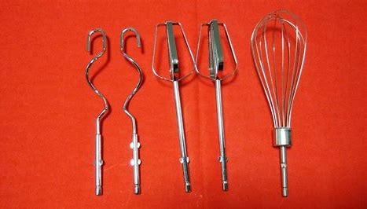
Figure. 3 A variety of mixing sticks

From the point of view of sustainable development, ABS plastic can be recycled[13], so the product has a certain recycling value. However, the switch assembly of the product contains some lead, which may cause environmental pollution. Manufacturers can consider replacing it with more environmentally friendly materials.

To sum up, Supor electric whisk is a good, fully functional product, basically meet the requirements of most users, with efficiency, ease of use, safety and other advantages. It occupies a large share of the low-end consumer market. However, it still needs to be optimized in terms of materials, multi-functional design and so on.

- Reference
[1] ‘【苏泊尔SDD2001】苏泊尔（SUPOR）打蛋器 家用电动打蛋机 迷你奶油打发器 烘焙手持自动搅蛋器搅拌器 SDD2001【行情 报价 价格 评测】-京东’. Accessed: Jun. 16, 2024. [Online]. Available: https://item.jd.com/100013382074.html
[2] ‘【荣事达EGK05Z】荣事达（Royalstar）打蛋器 电动家用无线手持打蛋机奶油打发器辅食搅拌机迷你烘焙打蛋器 充电式 EGK05Z【行情 报价 价格 评测】-京东’. Accessed: Jun. 16, 2024. [Online]. Available: https://item.jd.com/100061065520.html
[3] ‘【九阳S-LD150】九阳（Joyoung）手持电动打蛋器 料理机 打发器 多功能家用搅拌机迷你打奶油烘焙S-LD150【行情 报价 价格 评测】-京东’. Accessed: Jun. 16, 2024. [Online]. Available: https://item.jd.com/100007864601.html
[4] ‘【PAKCHOICE打奶器】PAKCHOICE电动打奶泡器咖啡奶泡打发器家用牛奶打泡器手持搅拌棒打蛋器【行情 报价 价格 评测】-京东’. Accessed: Jun. 16, 2024. [Online]. Available: https://item.jd.com/100098725714.html
[5] ‘The 7 Best Electric Whisks of 2024 (Reviews)’, FindThisBest. Accessed: Jun. 16, 2024. [Online]. Available: https://www.findthisbest.com/best-whisks/electric
[6] J. B. Tranter, P. Refalo, and A. Rochman, ‘Towards sustainable injection molding of ABS plastic products’, J. Manuf. Process., vol. 29, pp. 399–406, Oct. 2017, doi: 10.1016/j.jmapro.2017.08.015.
[7] ‘Materials | Free Full-Text | High-Performance of a Thick-Walled Polyamide Composite Produced by Microcellular Injection Molding’. Accessed: Jun. 16, 2024. [Online]. Available: https://www.mdpi.com/1996-1944/14/15/4199
[8] ‘The Price Of Abs And Pa66 Gf30-The Price Of Abs And Pa66 Gf30 Manufacturers, Suppliers and Exporters on Alibaba.comABS’. Accessed: Jun. 16, 2024. [Online]. Available: https://www.alibaba.com/trade/search?spm=a2700.product_home_newuser.home_new_user_first_screen_fy23_pc_search_bar.searchButton&tab=all&SearchText=The+price+of+ABS+and+PA66+GF30
[9] S. K. Vishwakarma, P. Pandey, and N. K. Gupta, ‘Characterization of ABS Material: A Review’.
[10] V. Gaitonde, S. Karnik, F. Mata, and J. P. Davim, ‘Modeling and Analysis of Machinability Characteristics in PA6 and PA66 GF30 Polyamides through Artificial Neural Network’, J. Thermoplast. Compos. Mater. - J THERMOPLAST COMPOS MATER, vol. 23, pp. 313–336, May 2010, doi: 10.1177/0892705709349319.
[11] ‘Lundberg 等 - 2017 - Surface integrity and fatigue behaviour of electri.pdf’.
[12] ‘Hysteretic performance of all-steel assembled double-cores buckling-restrained braces using Q195 low-yield core - ScienceDirect’. Accessed: Jun. 16, 2024. [Online]. Available: https://www.sciencedirect.com/science/article/pii/S0143974X21004077
[13] R. Scaffaro, L. Botta, and G. Di Benedetto, ‘Physical properties of virgin-recycled ABS blends: Effect of post-consumer content and of reprocessing cycles’, Eur. Polym. J., vol. 48, no. 3, pp. 637–648, Mar. 2012, doi: 10.1016/j.eurpolymj.2011.12.018.

